**Assignment – 3**

**Financial Analytics**

**Title : Analyzing competitive advantage in real companies**

**CONTENT**

* **Introduction**
* **Background**
* **Competitive advantage**
* **Financial performance evaluation**
* **Comparative analysis**
* **Assessment of sustainability**
* **Conclusion**

In this task I am analysing the competitive advantage of two real companies operating in different industries. One company from technology sector i.e. **APPLE** and another from the consumer goods sector i.e. **NESTLE**.

* **Introduction**
* **Company from technology sector :** **APPLE Inc**

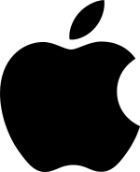

**Apple Inc.** (formerly **Apple Computer, Inc.**) is an American multinational corporation and technology company headquartered in Cupertino, California, in Silicon Valley. It designs, develops, and sells consumer electronics, computer software, and online services. Devices include the iPhone, iPad, Mac, Apple Watch, Vision Pro, and Apple TV; operating systems include iOS, iPadOS, and macOS; and software applications and services include iTunes, iCloud, Apple Music, and Apple TV.

For most of the period between 2011 and 2024, Apple was the world's largest company by market capitalization until it lost this position to Microsoft in January 2024.In 2022, Apple was the largest technology company by revenue, with US$394.3 billion. As of 2023, Apple was the fourth-largest personal computer vendor by unit sales, the largest manufacturing company by revenue, and the largest vendor of mobile phones in the world. It is one of the Big Five American information technology companies, alongside Alphabet (the parent company of Google), Amazon, Meta (the parent company of Facebook), and Microsoft.

* **Company from consumer goods sector** : **NESTLE**

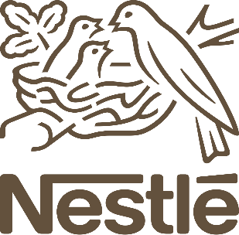

**Nestlé** is a Swiss multinational food and drink processing conglomerate corporation headquartered in Vevey, Switzerland. It has been the largest publicly held food company in the world, measured by revenue and other metrics, since 2014.It ranked No. 64 on the *Fortune* Global 500 in 2017. In 2023, the company was ranked 50th in the Forbes Global 2000.

Nestlé's products include baby food (some including human milk oligosaccharides), medical food, bottled water, breakfast cereals, coffee and tea, confectionery, dairy products, ice cream, frozen food, pet foods, and snacks. Twenty-nine of Nestlé's brands have annual sales of over 1 billion CHF (about US$1.1 billion), including Nespresso, Nescafé, Kit Kat, Smarties, Nesquik, Stouffer's, Vittel, and Maggi. Nestlé has 447 factories, operates in 189 countries, and employs around 339,000 people. It is one of the main shareholders of L'Oreal, the world's largest cosmetics company.

Nestlé was formed in 1905 by the merger of the "Anglo-Swiss Milk Company", which was established in 1866 by brothers George and Charles Page, and "Farine Lactée Henri Nestlé" founded in 1867 by Henri Nestlé.

* **Background**

1. **Company name : Apple Inc**

Apple Inc (Apple) designs, manufactures, and markets smartphones, tablets, personal computers, and wearable devices. The company offers software applications and related services, accessories, and third-party digital content. Apple’s product portfolio includes iPhone, iPad, Mac, iPod, Apple Watch, and Apple TV.

It also provides advertising services, payment services, cloud services, and various consumer and professional software applications such as iOS, macOS, iPadOS, watchOS, iCloud, AppleCare, and Apple Pay. Apple sells and delivers digital content and applications through the App Store, Apple Arcade, Apple News+, Apple Fitness+, Apple Card, Apple TV+, and Apple Music.

1. **Company name : Nestle**

Nestle is the largest food company in the world, in terms of revenue. It is a Swiss Company established in 1866 by its founder Henri Nestle. While its main foray is foods and drinks, it has hundreds of products, nearly 2000. Some of its most famous products and brands include Maggi, Kit Kat, Nespresso, Nescafe, etc.

The overall turnover for Nestle was approx 90 billion Swiss Franc in 2016. It operates 418 factories in 86 countries, employing nearly 339,000 people worldwide. Its products are available in 191 countries of the world. Nestle also is a leading researcher in the field of nutritional sciences. It invests nearly 1.5 billion Francs yearly on research and development.

* **Competitive advantages**

comparing competitive advantages of both the companies.

|  |  |  |
| --- | --- | --- |
| **Company name** | **APPLE Inc** | **NESTLE** |
| **Brand reputation** | Apple is viewed favourably for its “products and corporate performance,” but the company’s rating was hurt by poor performance from n its “citizenship” category. The Reputation Institute, an organisation that provides consulting services to corporate communications and marketing executives, conducts its study by surveying consumers and other stakeholders about their opinions on major companies, In 2017, Apple scored 74.94 in the study, down 1.7 compared to the prior year. | In its 2023 food and beverage report, Brand Finance values Nestlé brand at $20.8 billion, up from $19.4 billion, twice that of runner up, the Chinese dairy brand Yili at $10.6 billion.  Snack brand Lay's has increased in value to $8.6 billion from $6.6 billion – showing that many big food and beverage companies are getting bigger in the post-pandemic economy.  Hershey, the chocolate company, is ranked as the world’s “strongest” food brand, according to Brand Finance.  The fastest growing food brand is Belvita, a breakfast biscuit first introduced in France in 1998, which grew its value by more than 60% since last year |
| **Product differentiation** | In the ever evolving landscape of deception and disguise, product differentiation plays a viatl role in the market place. By patenting its unique designs and innovative features, apple can differentiate its products from competitors. The differentiation attracts consumers who value design and users experience. | Nestle brings a lot of product for target customers. They provide 25 types of minerals in Nido for children. It also provides Cerelac andLactogen1 &3 for newly born baby exclusively. Now the doctors prescribe these products for babies to their parents for high nutrition Nescafe is a product which contains 4 types of categories. They offer Nescafe ice for hot weather, classic for all 3 in 1 for those who are busy. They provide Maggi including Maggi instant; Maggi 2 minutes which contain various minerals, vitamins and nutrition’s. |
| **Technological innovation** | Nearly five decades after its founding, Apple has become one of the world’s most valuable companies. But beyond its $3 trillion market value, the technology supergiant has also shaped 21st-century society and culture. From the invention of the MacBook to the introduction of the iPhone, Apple paved the way for the world’s future generation of  technological products. Of all product releases over the years, here are six of the most groundbreaking Apple product innovations. Such as the mac, iPhone, iPod, iPad, apple watch, etc. | Nestle’s budget friendly innovaton strategy: ‘we are faster now than many of the startups” nestle launched and tested 12% more innovations in 2021 vs 2020, most of which offered meaningful differentiation in the market place, they claimed that, “they still have 30% of their growth coming from products they launched in the last three years. Other AI and data processing tools developed by nestle focused  on mining clinical data for new discoveries such as, 1) increasing innovation without increasing the R&D budget,2) focus on high growth categories increase innovation efficiencies and also partnerships for ongoing growth. |
| **Market leadership** | Apple is a leader in innovation and manages to set trends with each product it launches on the market, this has been proven time and time again, revolutionising the technological world.  We can highlight the following examples: 1) adaptation to customer needs, 2)commitment to design, 3) Quality before quantity 4) Excellent customer service. | Milk products and nutrition segment remains the largest contributor (40.4 per cent) to Nestle India’s sales and grew by 9.5 per cent y-o-y in 2022. Contribution of prepared dishes and cooking aids segment, led by brand Maggi, was pegged at 32.2 per cent and clocking a growth of 15.6 per cent y-o-y in 2022. “Maggi Noodles in 2022 saw the highest ever distribution and maintained market leadership as per Nielsen report,” the company added. |
| **Distribution network** | Apple is one of the leading technology companies in the world, making everything from phones to computers to earphones. They have really created a full ecosystem to connect all their products and services. Apple has 510 stores worldwide but also sells its products through third-party sellers and carrier providers. Components are made all over the world by specialist of each part and sent to two main assemblers in China to manufacture the final product, Foxconn and Pegatron. | Nestle has its own distribution network which is equipped with the all necessary facilities. It transports all of its products at major regional sales offices which are situated at different cities of the country. Nestle employ around 2,50,000 people from more than 70 countries and have factories or operations in almost every country in the world. Nestle is based on the principle of decentralization which means each country is responsible for the efficient running of the business. |

* **Analysing financial performance**
* **Analysing financial performance of**

**Technology company : APPLE**

1. **Revenue growth:** Apple today announced financial results for its fiscal 2024 first quarter ended December 30, 2023. The Company posted quarterly revenue of $119.6 billion, up 2 percent year over year, and quarterly earnings per diluted share of $2.18, up 16 percent year over year.

For the first quarter of their 2024 fiscal year, Apple reported a revenue of 119.6 billion U.S. dollars.

1. **Profit margins:**

Profit margin can be defined as the percentage of revenue that a company retains as income after the deduction of expenses. Apple net profit margin as of December 31, 2023 is 26.16%.

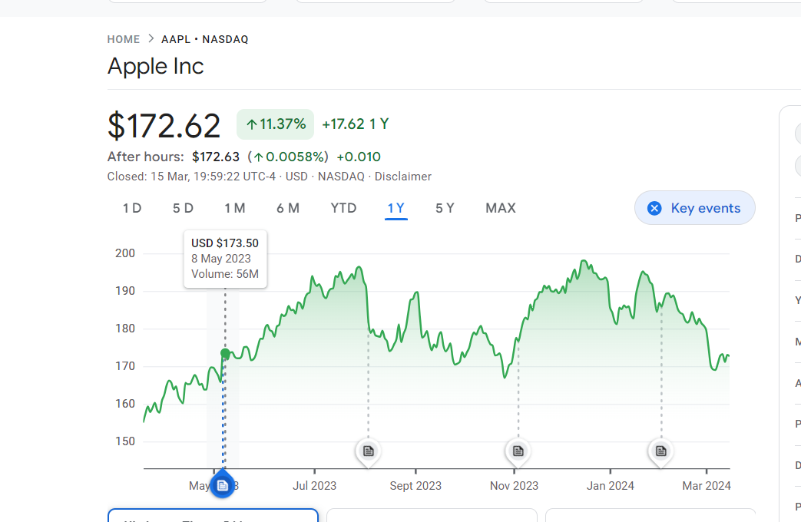

1. **Return on investment:**

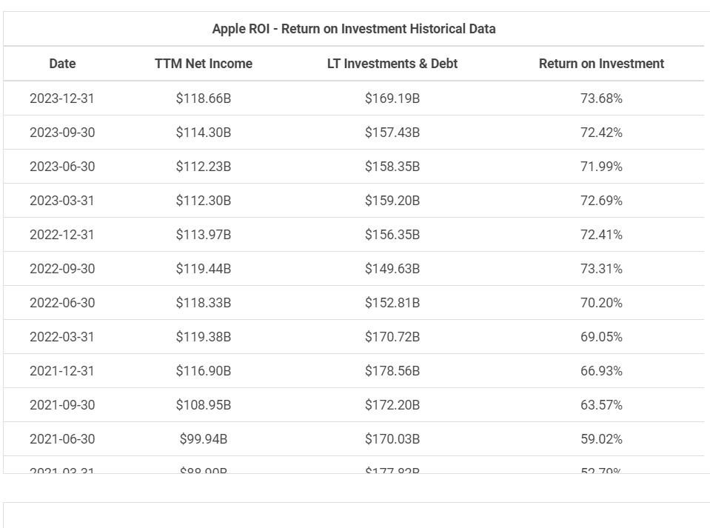

1. **Market share :**

Market share of Apple iPhone smartphone sales worldwide 2007-2023. Apple claimed a 24.7 percent share of the market in the fourth quarter of 2023, an increase from the previous quarter. Apple's long time competitor, Samsung, ranked first with a market share of 16.3 percent.

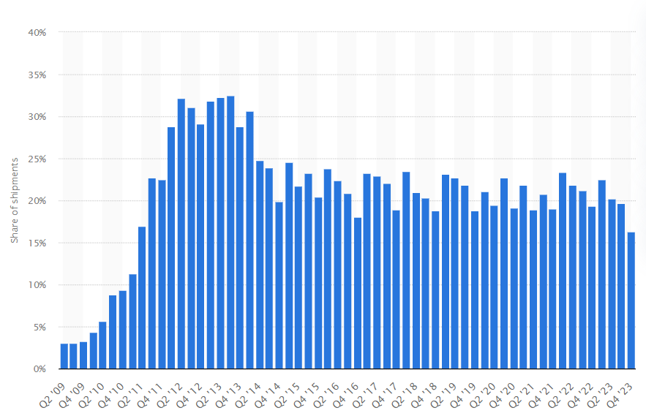

* **Analysing financial performance of**

**Consumer goods service company : NESTLE**

1. **Revenue growth:**

Organic growth reached 7.2%, with pricing of 7.5% and real internal growth (RIG) of -0.3%. Growth was broad-based across geographies and categories. Total reported sales were CHF 93.0 billion, a decrease of 1.5% (FY-2022: CHF 94.4 billion).

The underlying trading operating profit (UTOP) margin was 17.3%, increasing by 20 basis points on a reported basis and by 40 basis points in constant currency. The trading operating profit (TOP) margin was 15.6%, increasing by 160 basis points.

1. **Profit margin:**

FMCG major Nestle India on Wednesday reported a net profit of Rs 656 crore for the quarter ended December 2023, which is up 4% year-on-year (YoY) from Rs 628 crore posted in the same quarter last year. Revenue from operations rose 8% YoY to Rs 4,584 crore in the reporting fourth quarter.

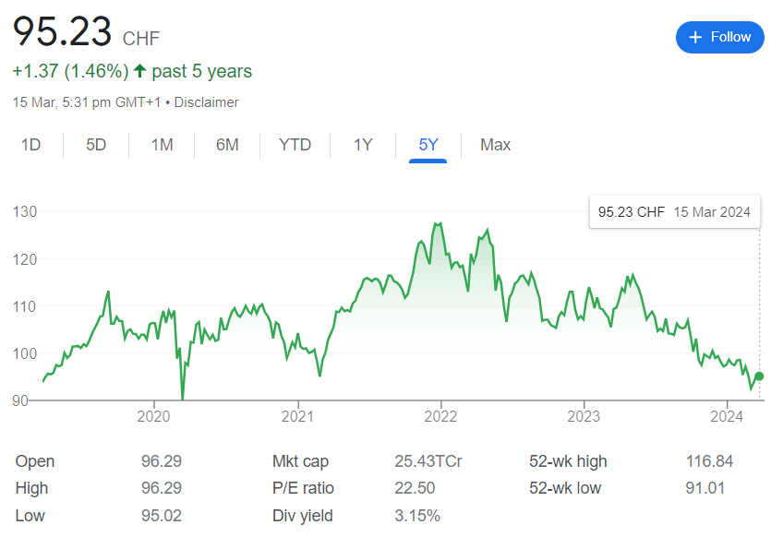

1. **Return on investment:**

Nestle SA DRC's return on invested capital hit its 5-year low in December 2021 of 12.8%. Nestle SA DRC's return on invested capital decreased in 2020 (13.2%, -3.8%) and 2021 (12.8%, -3.2%) and increased in 2019 (13.8%, +4.7%), 2022 (13.0%, +1.2%), and 2023 (13.6%, +4.8%).

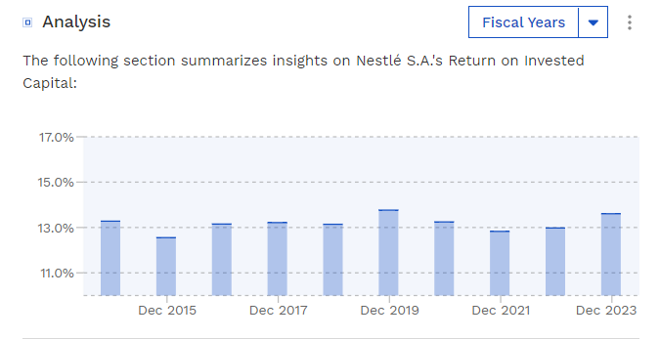

1. **Market share:**

As of March 2024 Nestlé has a market cap of $282.42 Billion. This makes Nestlé the world's 37th most valuable company by market cap according to our data.

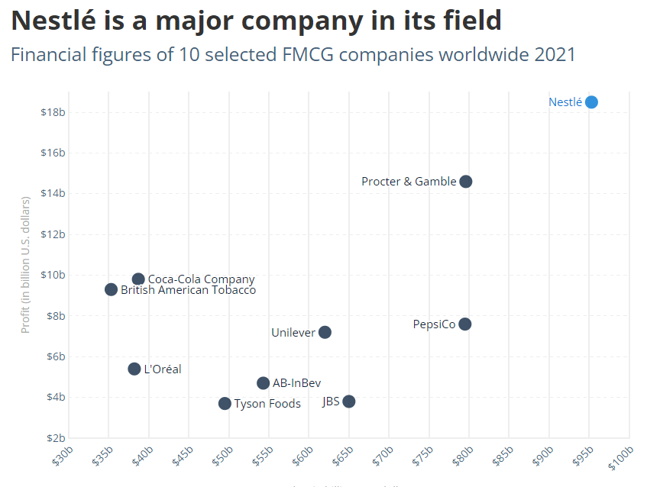

* **Compare competitive positions**

|  |  |  |
| --- | --- | --- |
| **Company name** | **Apple Inc** | **Nestle** |
| **Market share** | Market share of Apple iPhone smartphone sales worldwide 2007-2023. Apple claimed a 24.7 percent share of the market in the fourth quarter of 2023, an increase from the previous quarter. Apple's long time competitor, Samsung, ranked first with a market share of 16.3 percent. | In 2020, Nestle Cerelac, a product by Nestle India occupied 97 percent of the instant cereal market in India. This was followed by instant pasta occupying approximately 75 percent of the instant pasta market in India. Nestle India held a strong position, with most of its product categories having more than 50 percent of the market share in India. Nestle India is one of the largest FMCG companies in India specializing in food, beverages, chocolate, and confectioneries. |
| **Growth prospects** | Apple's Growth Strategies (Ansoff Matrix) product development. Apple uses product development as its main intensive strategy for growth. Product development requires that the company develop attractive and profitable technology products to grow its market share and business performance. | Its growth includes diverse products portfolio, global presence focus on nutrition and health, commitment to sustainability, and adaptability to changing market dynamics. |
| **Competitive threats** | Antitrust concerns and criticism of high app store fees relate to the power dynamics and control Apple exercises within its ecosystem, impacting competition and fair market practices. This goes beyond just business decisions and raises questions about governance, ethical conduct, and responsible use of market power. | Nestlé faces competition from a range of global companies in the food and beverage industry. Competitors include Unilever, PepsiCo, Coca-Cola, and Danone in the food and beverage segment. Mars, Mondelez International, Ferrero, and Hershey compete in confectionery. |
| **Barriers to entry** | **High capital requirements:**Building a company to compete with Apple would require significant investments in technology, R&D, and marketing.  **Brand recognition:** Apple has a strong brand that is well-known and respected worldwide. | The optimal barriers to enter the market includes product differentiation, government and legal requirements, capital requirements, economies of scale and others. (Kemp 2013, p. 112). For Nestle, they face a huge challenge to enter new markets due to the lack of product differentiation. |

* **Assessment of sustainability**

Sustainability assessment requires an evaluation of present and future conditions to show that present decisions and actions are not compromising future human and ecological health and well-being.

1. Technology company: **APPLE** **Inc**

Apple put sustainability at the centre of its Fall iPhone and Apple Watch event. It did so as it put sustainability into context by showing that you can do what I've been advocating for a long time: doing good and doing well from a business perspective.

Tim Cook opened up the event, saying Apple wants to make a difference as a company and with the products it brings to market. Apple Watch is the first carbon-neutral product that Apple launched, the first step towards its goal to have all Apple products be carbon-neutral by 2030.

It is important to take a moment to look at the steps that Apple is taking to achieve this goal. Apple’s first carbon-neutral products is a milestone in a journey initiated over a decade ago, involving substantial innovation and efforts throughout its global supply chain.

In 2020, the company reached carbon neutrality for its worldwide corporate operations and revealed the ambitious "Apple 2030" strategy to achieve carbon neutrality across its entire value chain by 2030. Central to this plan is a drastic 75% reduction of its total carbon emissions from the levels recorded in 2015. It has already diminished emissions by over 45% since 2015, even with revenue growing by over 65% within the same timeframe.

1. Consumer goods sector: **NESTLE**

“We believe in the power of food to enhance quality of life.”

This belief fuels our desire to use our global scale, resources and expertise to contribute to a healthier future for people and the planet.

Creating Shared Value (CSV) is at the heart of our purpose: to unlock the power of food to enhance quality of life for everyone, today and for generations to come.

Our approach to sustainability is wide-ranging, underpinned by commitments to strive for net zero emissions and deforestation-free supply chains and to advance regenerative agriculture at scale. We are also committed to improving water stewardship, developing better packaging to improve their end of life options, creating opportunities for young people and building a diverse and inclusive workforce.

Packaging helps to protect food and beverages, ensure product quality and freshness, communicate nutritional information and prevent food waste.

We aim to reduce our carbon footprint and achieve net zero by 2050 at the latest.

We take a holistic approach to managing our impact on the environment – joining the dots between climate change and related issues including water stewardship, biodiversity and human rights.

The ingredients we use for our products come from nature. That’s why playing our part in taking care of the environment and supporting a just future for communities is not only critically important for people and planet, it’s a business imperative too.

* **Conclusion**

1. **APPLE Inc**

Apple has changed the world through its products. The effects on consumers is phenomenon and only the future knows what products the Apple is going to bring to the market if their past trend is anything to go by, and it is likely to remain a giant for a long time. They have come up with products that people never imagined they needed, but once introduced to them they became hooked.

Apple is a maverick in the technology world, and the successful strategies they employ are likely to keep the company on an upward trend, consolidating its lead and market share. The company has huge cash reserves at its disposal that it can use to develop products.

Apple has accumulated significant cash reserves that have fortified its business. Even while the company faced multiple quarters of revenue declines this year, it continued to invest heavily in its high-growth industries like AI.

1. **NESTLE**

Overall, Nestle is a highly successful and profitable company with a strong reputation for quality and innovation. The company has a wide range of well-known and popular brands and a strong presence in the global market. Despite some challenges, such as concerns about environmental sustainability and criticism of the company's marketing practices, Nestle has generally been successful in navigating these issues and maintaining its position as a leader in the food and beverage industry.

Recommendations for improvement Nestle company: One area in which Nestle could improve is in its commitment to environmental sustainability. The company has faced criticism in the past for its use of unsustainable packaging and its impact on natural resources. To address these concerns, Nestle could invest in research and development of more sustainable packaging materials, as well as in initiatives to reduce waste and promote recycling.

Another area in which Nestle could improve is in its marketing practices, particularly with regard to the promotion of unhealthy products to children. The company has faced criticism in the past for its marketing of sugary drinks and other unhealthy products to children. To address these concerns, Nestle could adopt stricter guidelines for its marketing practices and prioritize the promotion of healthier products.

Nestle is the major player in the fast-moving consumer goods (FMCG) industry, but Nestle holds better long-term growth prospects. This is primarily due to its stronger brand portfolio, wider distribution network, and a larger presence in emerging markets.

***

**Name : G. Rama Prasanna**

**College : DR. Lankapalli Bullayya College**